PROJECT REPORT
Import Data using Transform Maps (Spreadsheet)
ServiceNow System Administrator – Group Project
Project Name | Import Data using Transform Maps (Spreadsheet)
Platform | ServiceNow (System Import Sets, Transform Maps, Reports)
Team ID | SWTID-2026-5226
Team Members | Monika R  Priyanka D  Archana K K  Nithyasree M  Pushpavalli B
Date | 3 October 2026

1. INTRODUCTION

1.1 Project Overview
Organisations often keep employee details in spreadsheets, and entering these records one by one into a platform is slow and error-prone. This project shows how to load employee data from a spreadsheet into ServiceNow in bulk, using Import Sets and Transform Maps.
The spreadsheet (Employee ID, Name, Email, Department, Location) is created in Google Sheets and downloaded as an .xlsx file. It is uploaded through Load Data into a staging table (Employee Import), then a Transform Map moves the validated rows into the target table (Employee Test). Coalesce on Employee ID makes repeated imports update existing records instead of creating duplicates. Finally, a report summarises the data by department.

1.2 Purpose
- Replace manual, record-by-record entry with a repeatable bulk import.
- Keep the target table clean by staging data first and mapping fields through a Transform Map.
- Prevent duplicate employee records by coalescing on Employee ID.
- Give visibility into every import through Transform History (inserted, updated, ignored).
- Present the imported data in a report that can be added to a dashboard.

2. IDEATION PHASE

2.1 Problem Statement
Element | Description
I am | A ServiceNow administrator responsible for maintaining employee records.
I am trying to | Load a large list of employees from a spreadsheet into a ServiceNow table.
But | Manual entry is slow, typing mistakes creep in, and running the load again creates duplicate records.
Because | There is no automated mapping between the spreadsheet columns and the table fields, and no check for existing records.
Which makes me feel | Frustrated by repetitive work and unsure whether the data in the system is correct.

2.2 Empathy Map Canvas
Persona: ServiceNow administrator / data coordinator.
Says | Thinks
“Can I load the whole employee list at once?”  “Why did this create duplicates?” | Typing hundreds of rows will take hours.  One wrong ID or email can break later records.
Does | Feels
Prepares the sheet in Google Sheets and downloads it as .xlsx.  Uploads it with Load Data and checks Transform History. | Frustrated by repetitive entry.  Worried about duplicates.  Relieved when the transform shows Success.

Pains | Gains
Slow manual entry  Typing errors  Duplicate records  No record of what changed | Fast bulk loading  Automatic field mapping  Update instead of duplicate  Insert / update / ignore counts  Charts of the data

2.3 Brainstorming
# | Idea | Pros / Cons | Decision
1 | Enter each employee manually through the form | Simple, but slow and error-prone | Rejected
2 | Upload a spreadsheet to an Import Set table and map it with a Transform Map | Fast, reusable, validates and maps fields | Selected
3 | Enable Coalesce on Employee ID | Updates matching records and avoids duplicates | Selected
4 | Show imported data as a pie chart by Department | Quick visual summary, can go on a dashboard | Selected
5 | Scheduled import from an external data source (JDBC / REST) | Fully automatic, but needs an external system | Future scope

3. REQUIREMENT ANALYSIS

3.1 Customer Journey Map
Stage | Customer action | Touchpoint | Experience | Opportunity
Prepare data | Create the sample spreadsheet and download as .xlsx | Google Sheets | Easy, familiar tool | Use a standard column layout
Create tables | Create Employee Test table and add form fields | Tables, Form Layout | Some care needed with field names | Reuse the table for later imports
Load data | Upload the file into Employee Import | System Import Sets > Load Data | Straightforward | Header row set to 1
Transform | Create the Transform Map, auto-map fields and run it | Transform Maps | Relief when State shows Success | Auto Map Matching Fields saves time
Validate | Check Employee Test records and Transform History | Employee Test list, Transform History | Confident the data is correct | Adjust list columns as needed
Report | Create the Employees by Department report | Reports | Satisfying to see the summary | Add the report to a dashboard

3.2 Solution Requirements
Functional requirements
ID | Requirement | Description
FR-1 | Source spreadsheet | Sample spreadsheet with Employee ID, Name, Email, Department and Location, saved as Sample Spreadsheet.xlsx.
FR-2 | Target table | Custom table Employee Test (u_employee_test) with String fields for all five columns.
FR-3 | Staging table | Employee Import (u_employee_import) created through Load Data, header row 1.
FR-4 | Transform Map | Sample Spreadsheet Import maps Employee Import to Employee Test using Auto Map Matching Fields.
FR-5 | Validation | Imported rows are checked in the Employee Test list; field layout is adjusted with Personalize List Columns.
FR-6 | Duplicate control | Coalesce enabled on the Employee ID field map so existing records are updated.
FR-7 | Reporting | Pie chart report “Employees by Department” grouped by Department with Count.

Non-functional requirements
Attribute | Requirement
Usability | Steps should be easy to follow using standard ServiceNow modules and the application navigator.
Data integrity | No duplicate Employee IDs; every transform run is recorded in Transform History.
Reliability | Re-running the same file must not change or duplicate existing data.
Security | Import and transform actions are performed by users with administrator access.
Maintainability | The same staging table and Transform Map can be reused for new files with the same layout.

3.3 Data Flow Diagram
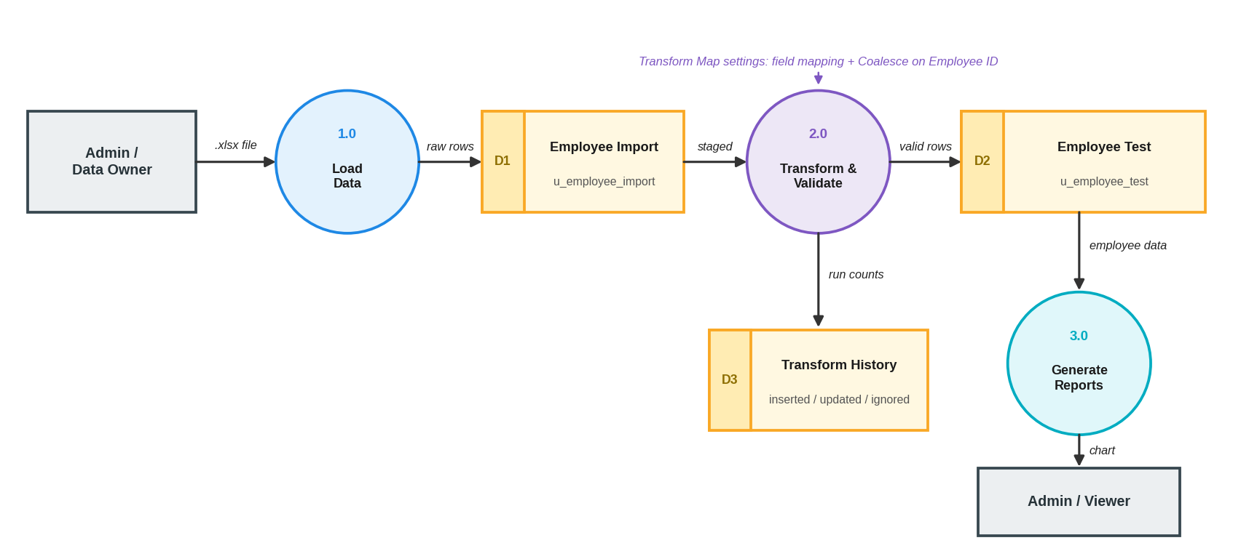
Figure 1: Data flow diagram of the spreadsheet import
The administrator supplies the .xlsx file to process 1.0 (Load Data), which writes raw rows to the Employee Import table (D1). Process 2.0 (Transform & Validate) reads the staged rows, applies the Transform Map and writes valid records to Employee Test (D2), while the result counts are stored in Transform History (D3). Process 3.0 (Generate Reports) reads D2 and presents the department chart to the viewer.

3.4 Technology Stack
Layer | Technology
Source data | Google Sheets; Microsoft Excel (.xlsx)
Platform | ServiceNow instance
Data model | Custom tables Employee Test (u_employee_test) and Employee Import (u_employee_import); String fields
Data loading | System Import Sets: Load Data, Transform Maps, Transform History
Reporting | ServiceNow Reports (pie chart) and dashboards
Client | Web browser (Google Chrome)
Project tracking | SkillWallet group project workspace (milestones and Kanban)

4. PROJECT DESIGN

4.1 Problem Solution Fit
Problem | Solution | Fit
Slow, manual record entry | Bulk load from a spreadsheet through Import Sets | Hours of typing reduced to one upload
Spreadsheet columns differ from table fields | Transform Map with field maps | Fields are mapped once and reused
Duplicate employee records on re-import | Coalesce on Employee ID | Matching records are updated, not duplicated
No visibility of import results | Transform History counts | Inserted, updated and ignored rows are visible
Data is hard to summarise | Pie chart report by Department | Instant overview for dashboards

4.2 Proposed Solution
Parameter | Description
Problem to be solved | Efficiently and accurately load employee data from a spreadsheet into ServiceNow without duplicates.
Solution | Stage the data in an Import Set table, convert it with a Transform Map, coalesce on Employee ID and report on the result.
Key features | Spreadsheet upload; automatic field mapping; insert / update / ignore handling; Transform History; Employees by Department chart.
Business value | Saves administrator time, improves data quality and gives managers a quick view of staffing by department.
Scalability | The same map works for larger files with the same layout; more fields or tables can be added later.

4.3 Solution Architecture
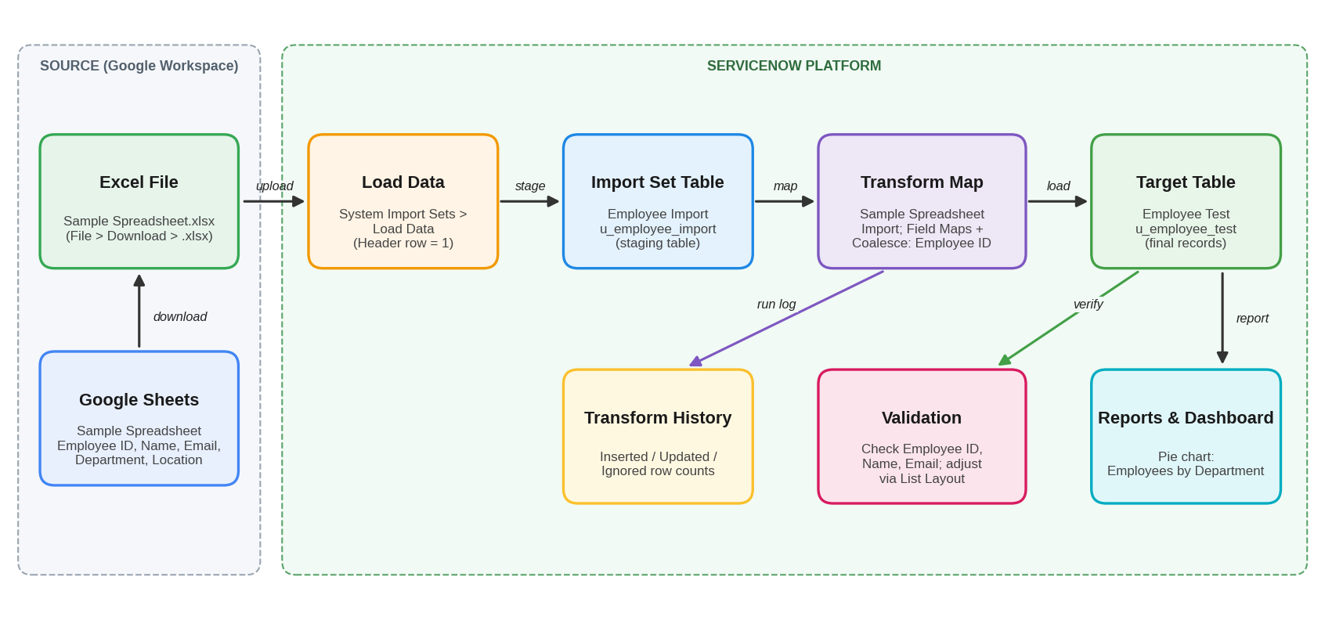
Figure 2: Solution architecture of the spreadsheet import using Transform Maps
The architecture has two zones. In the source zone, data is prepared in Google Sheets and exported to Excel. In the ServiceNow zone, Load Data places the file in the Import Set table; the Transform Map converts rows into the Employee Test table; and Transform History, validation and reports provide checking and visibility.

5. PROJECT PLANNING & SCHEDULING

5.1 Project Planning
The project was planned as four milestones, each broken into short stories assigned to team members and tracked on the SkillWallet workspace.
Milestone | Story | Assigned to | Status
1. Creation of Spreadsheet and Table | Creation of Spreadsheet | Monika R | In Review
 | Creation of Tables | Priyanka D | In Review
2. Creation of Import Set Table and Transform Map | Create Import Set Table | Archana K K | In Review
 | Create Transform Map | Archana K K | In Review
3. Transform Data & Validate and Enable Coalesce | Transform Data & Validate | Priyanka D | In Review
 | Enable Coalesce to Avoid Duplicate Records | Nithyasree M | In Review
 | Inserting New Data in Excel Format | Pushpavalli B | In Review
4. Creation of Reports & Dashboards | Report 1 (Employees by Department) | Pushpavalli B | In Review
 | Adding Reports to Dashboard | – | Planned
Overall progress on the project board: 90% (each of the four milestones shows 90%).

6. FUNCTIONAL AND PERFORMANCE TESTING

6.1 Performance Testing
The import was tested by running the Transform Map several times and checking the Transform History counts and the Employee Test table.
Test | Scenario | Expected result | Observed result
TC-1 | Load the sample spreadsheet and run the Transform Map | Employee records created in Employee Test; State: Complete, Success | Records created; transform completed successfully
TC-2 | Upload a file with 4 rows: 2 new Employee IDs and 2 existing IDs with changed Name / Email (Coalesce on Employee ID) | 2 inserted, 2 updated | 4 rows processed: 2 inserted, 2 updated
TC-3 | Upload the same 4-row file again | No new inserts, no duplicates | 0 inserted, 0 updated, 4 ignored
TC-4 | Create the Employees by Department pie chart (group by Department, aggregation Count) | Report runs and can be saved | Chart displayed and saved
Counts above were read from the Transform History screenshots in the project workspace.

7. RESULTS

7.1 Output Screenshots
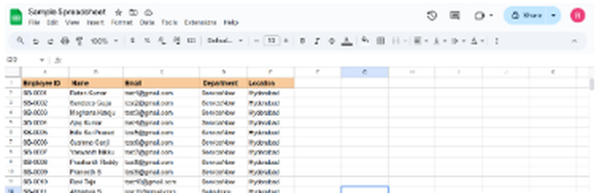
Figure 3: Sample spreadsheet with employee data (Google Sheets)
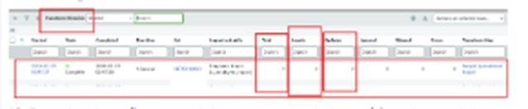
Figure 4: Transform History for the first run (inserted and updated rows)
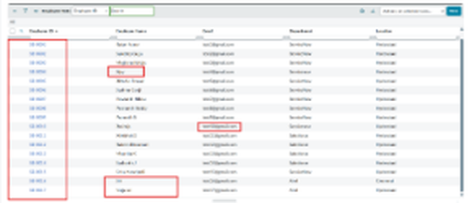
Figure 5: Employee Test table showing the imported and updated records
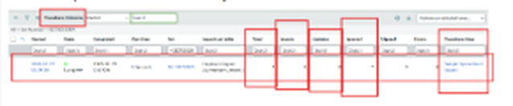
Figure 6: Transform History when the same file is imported again (rows ignored)
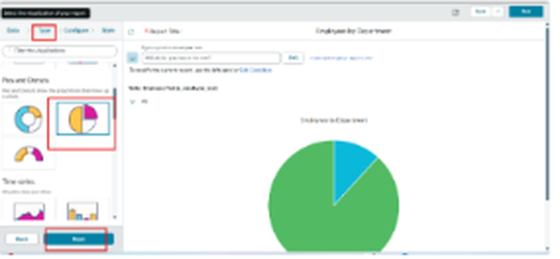
Figure 7: Selecting the pie chart type for the report
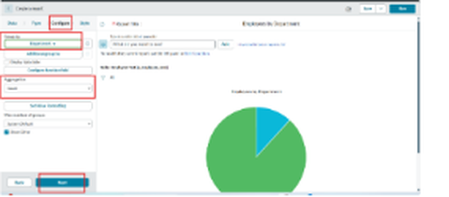
Figure 8: Employees by Department report grouped by Department with Count

8. ADVANTAGES & DISADVANTAGES
Advantages
- Bulk loading saves time compared with manual entry.
- Staging table keeps raw data separate from the final table.
- Coalesce on Employee ID prevents duplicate records and updates changed data.
- Transform History gives a clear record of inserted, updated and ignored rows.
- The same Transform Map can be reused for later files with the same layout.
- Report gives a quick overview of employees by department.
Disadvantages
- The import is manual: someone must upload the file each time.
- The spreadsheet columns must match the expected layout, or the map needs changing.
- Only basic validation is applied; wrong but well-formed values are still accepted.
- Only one source file type (Excel) and one target table are covered.

9. CONCLUSION
The project achieved its aim of importing employee data from a spreadsheet into ServiceNow using an Import Set table and a Transform Map. Testing showed that new records are inserted, changed records are updated through Coalesce on Employee ID, and re-importing the same data does not create duplicates. The Employees by Department report summarises the loaded data. Together these steps give administrators a faster, cleaner and more traceable way to bring spreadsheet data into ServiceNow.

10. FUTURE SCOPE
- Automate imports with a scheduled data source (for example JDBC or REST) instead of manual uploads.
- Add transform scripts and stronger validation, such as email format and mandatory-field checks.
- Import into related tables (for example linking employees to departments or locations).
- Add more reports and place them on a dashboard with filters.
- Notify the administrator when an import finishes or has errors.

11. APPENDIX

Source Code (if any)
The solution is built through ServiceNow configuration rather than custom code. The key settings are:
Item | Configuration
Target table | Employee Test (u_employee_test): Employee ID, Employee Name, Email, Department, Location (all String)
Import Set table | Employee Import (u_employee_import), created with System Import Sets > Load Data, header row 1
Transform Map | Sample Spreadsheet Import: source Employee Import, target Employee Test, Auto Map Matching Fields
Coalesce | Enabled on the Employee ID field map
Report | Employees by Department: source Table (Employee Test), type Pie chart, group by Department, aggregation Count

Dataset Link
Sample Spreadsheet (employee data): [add Google Sheets / Drive link here]

GitHub & Project Demo Link
GitHub / Repo: [add link here]
Project Demo: [add link here]

